SCHOOL NAME:BLOSSOM ACADEMY
PROGRAM:DATA ANALYTICS
COHORT:KIGALI RWANDA
STUDENT NAME:Marie Solange UWERA

WASTE MANAGEMENT IN KIGALI CITY PROJECT

Despite Kigali City’s strong commitment to cleanliness and environmental protection, household waste management remains a challenge in many areas. Some households do not properly separate waste, others experience irregular waste collection services, and some residents have limited awareness of waste management rules and best practices.

Improper waste management can lead to environmental pollution, public health risks, blocked drainage systems, and increased waste management costs. However, there is limited household-level data on waste generation, waste separation practices, awareness levels, and challenges faced by residents in Kigali City. Without such data, it is difficult for authorities and service providers to design effective waste management interventions.

This study aims to address this gap by collecting and analyzing household waste management data using a Kobotoolbox survey and analyze it.

Objective of this Study are:

To assess household waste management practices among residents of Kigali City.

To identify the most common types of household waste generated in Kigali City.

To determine the level of household waste separation practices.

To assess the frequency and methods of waste collection services.

To evaluate residents’ awareness of waste management rules and guidelines.

To identify challenges faced by households in managing waste.

To examine residents’ attitudes toward proper waste management and environmental protection.

The findings of this study will be useful to the following stakeholders:

- Kigali City Authorities to improve waste management policies and monitoring strategies.

- Waste Collection Companies to understand service gaps and improve collection efficiency.

- Environmental Agencies and NGOs to design targeted awareness and education campaigns.

- Local Leaders and Community Organizations to promote community participation in waste management.
- Researchers and Students as reference material for future studies on urban waste management.

- Residents of Kigali City to increase awareness and encourage better waste management practices.

KoboToolbox data collection form

https://ee.kobotoolbox.org/x/CeDjXikf

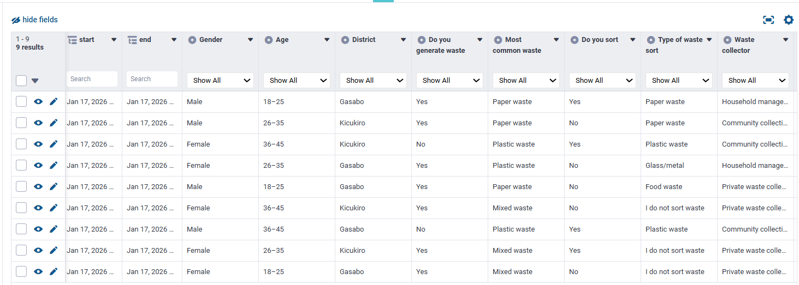

Here attached below the link for raw data structure :

https://kf.kobotoolbox.org/#/forms/aWRvnAAC4qxiV86SY6JmHa/data/downloads

PYTHON ETL SCRIPT AND DATA IN POSTGRESQL

import pandas as pd
import requests
import io
import psycopg2
from requests.auth import HTTPBasicAuth
import os

# 1. Configuration
KOBO_API_TOKEN = "55709dfbbffad50be70c72bd30c55ce623bcae6d"
KOBO_CSV_URL = "https://kf.kobotoolbox.org/api/v2/assets/aWRvnAAC4qxiV86SY6JmHa/export-settings/esrxUHk4AQr4wAQBx6SRuKC/data.csv"

print("Fetching data from KoboToolbox...")
response = requests.get(KOBO_CSV_URL, headers={"Authorization": f"Token {KOBO_API_TOKEN}"})

if response.status_code == 200:
print("✅ Data fetched successfully")
csv_data = io.StringIO(response.text)
df = pd.read_csv(csv_data, sep=';', on_bad_lines='skip')

# IMPORTANT: Only strip whitespace, don't remove spaces yet so we can match the SQL
df.columns = [col.strip() for col in df.columns]

# Database connection
try:
conn = psycopg2.connect(
dbname="postgres",
user="postgres",
password="NGOGAshami@2024",
host="localhost",
port="5432"
)
cur = conn.cursor()

print("Uploading data to PostgreSQL...")

# Create schema and table
cur.execute("CREATE SCHEMA IF NOT EXISTS waste_management;")
cur.execute("DROP TABLE IF EXISTS waste_management.waste_management_project;")

cur.execute("""
CREATE TABLE waste_management.waste_management_project (
id SERIAL PRIMARY KEY,
"start" TIMESTAMP,
"end" TIMESTAMP,
"Gender" TEXT,
"Age" TEXT,
"District" TEXT,
"Do you generate waste" TEXT,
"Most common waste" TEXT,
"Do you sort" TEXT,
"Type of waste sort" TEXT,
"Waste collector" TEXT,
"How often" TEXT,
"Know the rules" TEXT,
"Source of information" TEXT,
"Waste challenges" TEXT,
"Plastic waste handling" TEXT,
"Proper waste management is it important" TEXT,
"How to improve waste management" TEXT
);
""")

insert_query = """
INSERT INTO waste_management.waste_management_project (
"start", "end", "Gender", "Age", "District",
"Do you generate waste", "Most common waste", "Do you sort",
"Type of waste sort", "Waste collector", "How often",
"Know the rules", "Source of information", "Waste challenges",
"Plastic waste handling", "Proper waste management is it important",
"How to improve waste management"
) VALUES (%s, %s, %s, %s, %s, %s, %s, %s, %s, %s, %s, %s, %s, %s, %s, %s, %s)
"""

for _, row in df.iterrows():
cur.execute(insert_query, (
row.get("start"),
row.get("end"),
row.get("Gender"),
row.get("Age"),
row.get("District"),
row.get("Do you generate waste"),
row.get("Most common waste"),
row.get("Do you sort"),
row.get("Type of waste sort"),
row.get("Waste collector"),
row.get("How often"),
row.get("Know the rules"),
row.get("Source of information"),
row.get("Waste challenges"),
row.get("Plastic waste handling"),
row.get("Proper waste management is it important"),
row.get("How to improve waste management")
))

conn.commit()
print("✅ Data successfully loaded! Refresh pgAdmin to see the values.")

except Exception as e:
print(f"❌ Database Error: {e}")
if 'conn' in locals(): conn.rollback()
finally:
if 'cur' in locals(): cur.close()
if 'conn' in locals(): conn.close()
else:
print(f"❌ Failed to fetch data. Status: {response.status_code}")

